Data Analytics Internship

A Project Report submitted to the
Global Next Consulting India Private Limited (GNCIPL)
By
Name of Group members
Yogeshwaran N
Soumyadeep Bhattacharyya
Ramkrishna Ghosh
Under the Supervision of

Ms. Abhipsa Guha
(Project Director)
GLOBAL NEXT CONSULTING INDIA PVT LTD


December, 2025

Project Name : (13) Flood Risk Prediction
1. Introduction
Floods are among the most devastating natural disasters, causing significant loss of life, infrastructure damage and economic disruption. Accurate flood risk prediction is essential for disaster preparedness, early warning systems and sustainable urban planning. This project focuses on predicting flood risk zones by integrating historical rainfall, river level and geospatial data using data science, machine learning and GIS-based visualization techniques.
The project follows an end-to-end data analytics pipeline, starting from data collection and preprocessing to predictive modeling and dashboard-based visualization for decision support.

2. Objectives
The primary objectives of this project are:
- To analyze historical rainfall and river level data to understand flood patterns.
- To predict flood occurrence (classification) and flood severity (regression).
- To identify high-risk flood zones using spatial (GIS) analysis.
- To develop an interactive dashboard for flood risk monitoring and early warning support.

3. Data Sources
Multiple heterogeneous data sources were integrated to capture hydrological, meteorological and geographical factors influencing floods:
- Historical rainfall data (mm)
- River gauge readings (river level and flow rate)
- Meteorological parameters (temperature, humidity, wind speed, wind direction)
- Topographic data (elevation)
- Land-use / land-cover data
- Soil texture classification
- Urban indicators (impervious surface percentage, population, population density)
These datasets were collected in different formats and resolutions and later unified into a single analytical dataset.

4. Tools and Technologies Used
4.1 Programming & Analysis
- R: Data cleaning, basic statistical visualizations
- Python: ETL process, preprocessing, Feature engineering, exploratory data analysis (EDA), machine learning modeling (classification and regression)
4.2 GIS & Visualization
- Python GIS Libraries: Seaborn, Matplotlib GeoPandas, Contextily for spatial analysis.
- Tableau: Interactive dashboards and KPI-based flood risk visualization

5. Methodology
5.1 Data Integration (ETL) :
Rainfall, river, meteorological and geospatial datasets were merged based on spatial (latitude–longitude, city) and temporal (date) attributes. This integration enabled a unified view of flood-influencing factors.
5.2 Data Cleaning (R) :
- Removal of duplicate records.
- Handling missing values using statistical imputation.
- Standardization of column names and data types.
- Filtering inconsistent and noisy observations.
5.2.1 Dataset Loading and Environment Setup
The dataset used for this project was loaded into the R environment using the read.csv() function. To support efficient data manipulation and visualization, essential R libraries such as dplyr, ggplot2 and reshape2 were installed and loaded. These libraries provide powerful tools for data wrangling, exploratory analysisand visualization.
The dataset contains meteorological, hydrological, geographical and demographic attributes related to flood risk assessment across multiple cities.
5.2.2 Data Type Correction
Proper data types are essential for accurate analysis and modeling. The following conversions were performed:
- The timestamp column was converted from character format to Date format to enable time-series analysis.
- Categorical attributes such as City, landcover_class and soil_texture_class were converted into factor data types.
- The structure of the dataset was verified using the str() function to ensure all variables were correctly assigned.
This step ensured compatibility with visualization functions and future machine learning models.
5.2.3 Missing Value Assessment
A systematic check for missing values was performed using the is.na() function across all columns. Column-wise summaries confirmed that the dataset contained no critical missing values, indicating high data quality.
A comprehensive statistical summary of the dataset was generated to further validate the distribution and consistency of numerical and categorical variables.
5.2.4 Column Renaming for Standardization
To improve readability and maintain consistency across the project, column names were standardized using the rename() function from dplyr. Long and complex attribute names were simplified while preserving their semantic meaning.
Examples include:
- temp_C → temp_c
- humidity_. → humidity_percentage
- impervious_percent_ghsl_2018_15km2 → impervious_percent
- worldpop_total_pop_2020_10km2 → city_population
This step enhanced clarity and reduced the likelihood of errors during analysis and model development.

5.2.5 Outlier Detection
Outlier detection was conducted using boxplots, which are effective in identifying extreme values in numerical data.
Key hydrological and meteorological variables analyzed:
- River level
- Flow rate
- Rainfall (mm)
- Elevation
- Impervious surface percentage
- Temperature
- Population density
Data was reshaped into long format using the reshape2 package, allowing multiple variables to be visualized in a single chart. The detected outliers were reviewed and retained, as extreme values are often realistic and critical indicators in flood risk analysis.
5.2.6 Exploratory Data Visualization
Several visualizations were created to understand data distribution and temporal trends:
Histogram Analysis
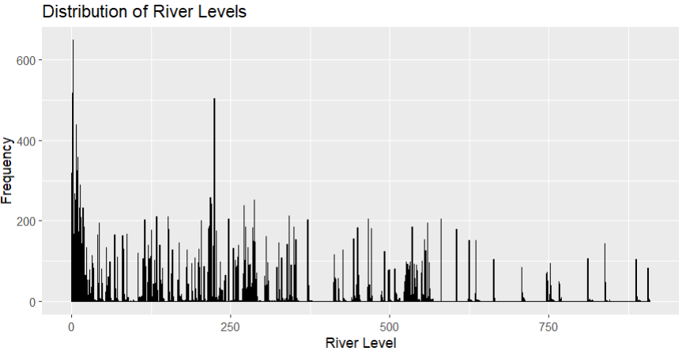
- A histogram of river levels was used to analyze distribution patterns and identify potential skewness.

Time-Series Analysis
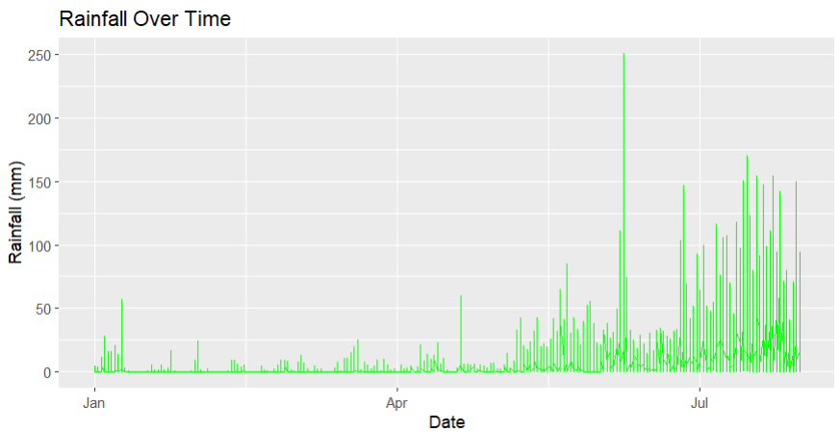
- Rainfall trends over time were visualized using a line plot, highlighting seasonal variations and extreme rainfall events.

Monthly Flow Rate Comparison
- A boxplot of flow rate by month was generated to examine monthly variability and peak flow periods.
These visualizations provided valuable insights into flood-related behavior patterns.
5.2.7 Column Removal
Redundant or less informative columns, such as numeric land cover and soil texture codes, were removed to reduce dimensionality and improve model efficiency.
The cleaned dataset retained only the most relevant attributes required for flood risk prediction.

5.3 Data Preprocessing :
- Normalization and scaling of numerical features
- Encoding of categorical variables such as landcover class and soil texture
- Date-time parsing and temporal feature extraction
5.3.1 Feature Engineering (Python) :
New features were derived to enhance model performance:
- Rainfall intensity indicators
- River level deviation measures
- Urbanization indicators (impervious percentage, population density)
- Temporal features (month, season)
These engineered features helped capture nonlinear flood dynamics more effectively.

5.5 Exploratory Data Analysis (EDA) :
EDA was performed using Python to understand data distributions and relationships:
- Statistical summaries of rainfall and river levels
- City-wise and seasonal rainfall analysis
- Correlation analysis between rainfall, river level and flood indicators
- Landcover vs rainfall and river level comparisons
- Spatial distribution of flood-prone regions using latitude–longitude mapping
EDA revealed strong correlations between heavy rainfall, high river levels, low elevation areas and increased flood risk.

5.6 EDA part:
6.1 Rainfall over month
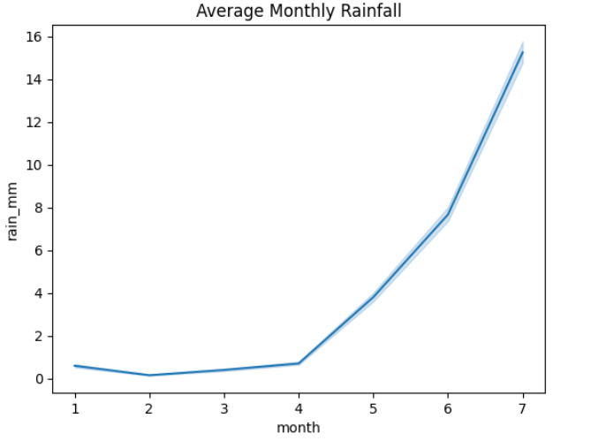
- Rainfall remains minimal during the initial months and increases sharply after Month 4, indicating a strong seasonal pattern with a concentrated rainfall period.The rapid rise in rainfall during the later months
- significantly elevates flood risk, highlighting the need for early preparedness before the monsoon peak.

6.2 Monthly river level trend
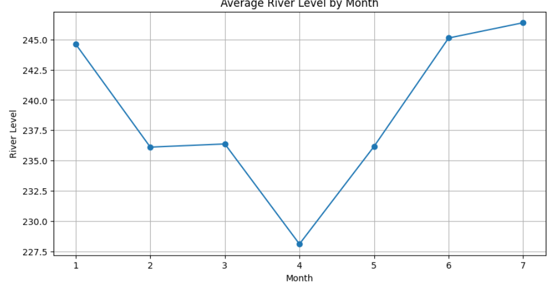
- River levels remain relatively high and stable during the early months, followed by a noticeable dip around Month 4, indicating a temporary reduction in water accumulation.
- A sharp rise in river levels from Month 5 onwards aligns with increased rainfall, signaling a higher likelihood of flooding during the later months.

6.3 Top 8 cities based on both rainfall & river level
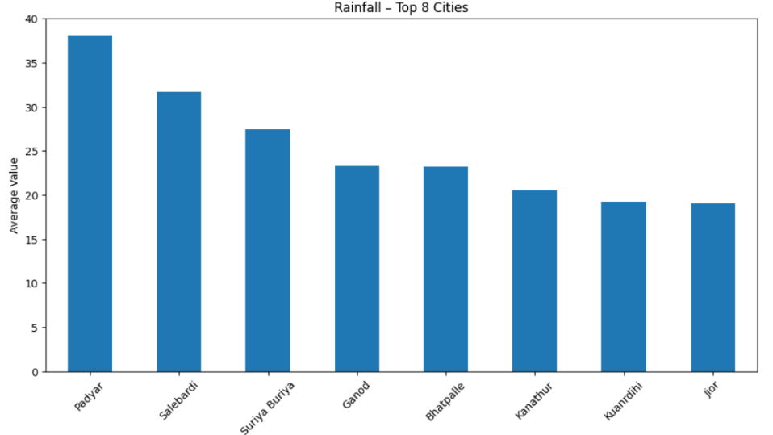
- Padyar and Salebardi record the highest average rainfall among the top cities, while Suriya Buriya, Ganod and Bhatpalle experience comparatively moderate rainfall levels, indicating clear spatial variation in rainfall distribution across high-risk cities.

- The river level distribution across the top cities shows that higher rainfall does not necessarily result in higher river levels, indicating that flood risk is influenced by additional factors such as river connectivity, drainage efficiency, upstream inflow and local topography.
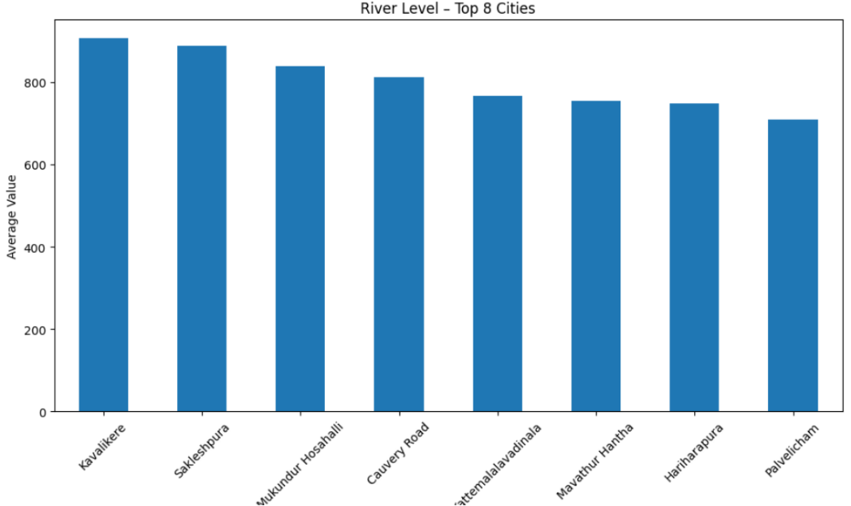

6.4 Avg Rainfall over Land class :
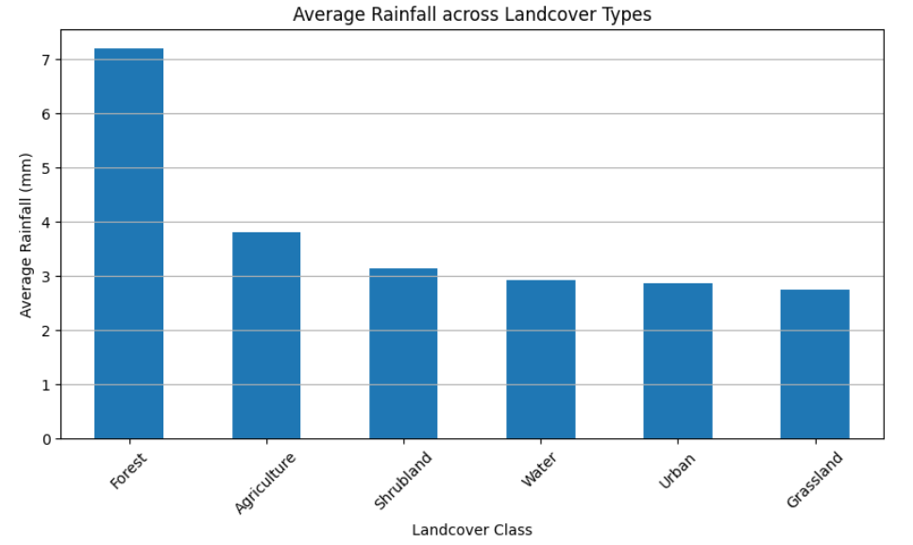
- Forest landcover exhibits the highest average rainfall, highlighting its strong association with high-precipitation zones and moisture-rich climatic conditions.
- Urban and grassland areas record comparatively lower rainfall levels, indicating the influence of landcover type on rainfall distribution and localized microclimatic variations.

6.5 Comparing Rainfall & River level
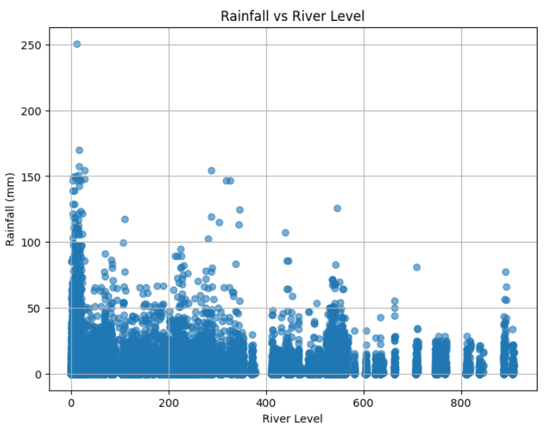
• The scatter plot shows a weak direct correlation between rainfall and river level, indicating that high river levels can occur even during periods of low or moderate rainfall.
• Clusters of high river levels with low rainfall suggest the influence of upstream discharge, reservoir releases, or catchment storage effects, highlighting the complexity of flood dynamics beyond local rainfall alone.

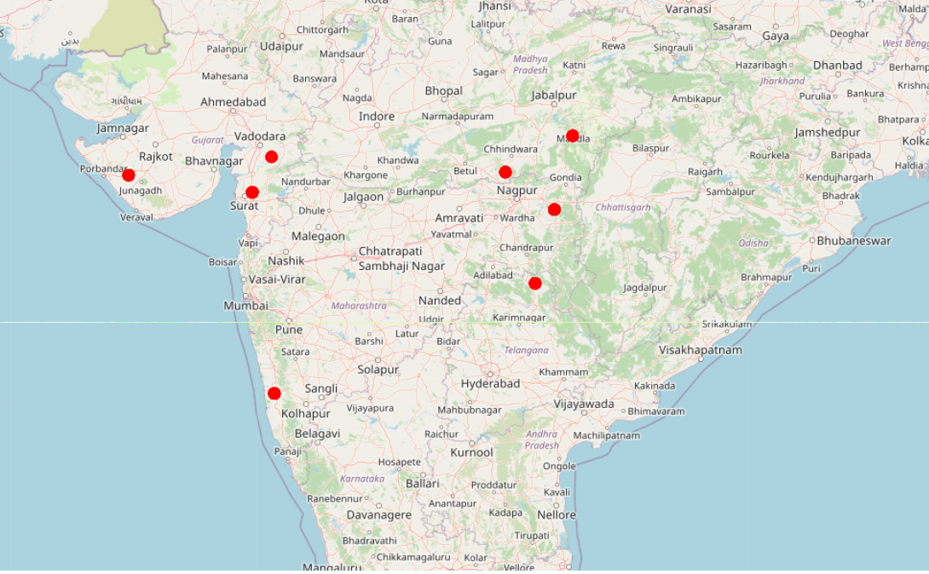
6.6 Top 8 Cities comparing Rainfall & River level

Spatial Analysis and GIS Mapping in 6.6 & 6.7
GIS-based analysis was performed to visualize flood risk spatially:
- Conversion of latitude–longitude data into GeoDataFrames
- Overlaying flood indicators on OpenStreetMap basemaps
- Visualization of rainfall intensity (marker size) and river level severity (color scale)
Spatial clustering revealed geographic flood hotspots, particularly in regions with high rainfall and elevated river levels.
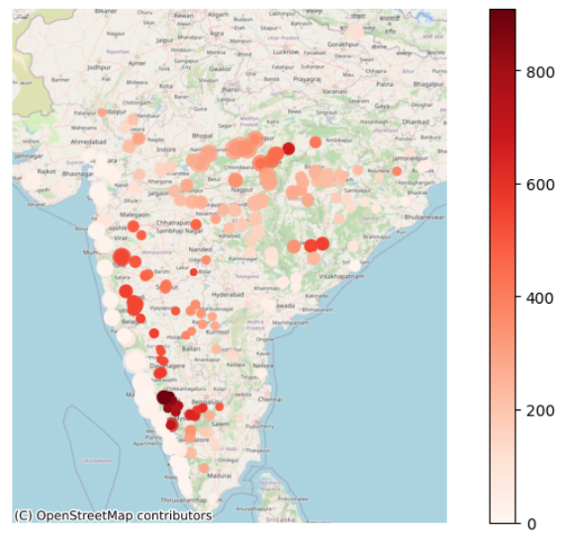
6.7 Spatial Flood Risk Pattern

5.7 Feature Engineering :
Feature engineering plays a critical role in capturing the temporal dynamics of floods, which are strongly influenced by accumulated rainfall, upstream flow memory and terrain characteristics.
5.7.1. Log Transformation
To handle skewness and stabilize variance in hydrological variables, it can balance the data :
- log1p(flow_rate)
- log1p(river_level)
were applied, ensuring numerical stability and improving model convergence.
5.7.2. Lag Features
Flood behavior depends heavily on previous days’ conditions. Therefore, city-wise lag features were created:
- 1-day lag rainfall
- 1-day lag river level
- 1-day and 2-day lag flow rate
These features help the model capture short-term hydrological memory effects.
5.7.3. Rolling Window Features
To represent cumulative and delayed flood responses, rolling features were computed:
- 3-day and 7-day cumulative rainfall
- 3-day and 7-day mean flow rate
- 7-day mean river level
These rolling statistics allow the model to understand sustained rainfall and prolonged high-flow conditions that typically precede flood events.
5.7.4. Trend & Change Indicators
Additional trend-based features were included:
- Day-to-day river level change
- Rainfall change from the previous day
These indicators assist in detecting sudden rises that often signal flash flooding.
5.7.5. Encoding of Categorical Variables
Categorical attributes were transformed using label encoding:
- Soil texture class
- Landcover type
- City identifier
This enabled the use of tree-based machine learning models without losing categorical information.
5.7.6. Train–Test Temporal Split
To avoid data leakage and ensure realistic prediction:
- January–June data was used for training.
- July data was reserved for testing.
This chronological split mimics real-world flood forecasting scenarios.

5.8 Machine Learning Modeling :
Overview of Modeling Approach
The flood risk system adopts a hybrid modeling strategy consisting of:
- Regression modeling to predict:
  - River water level
  - River flow rate
- Risk classification, derived from regression prediction errors using a severity-based scoring mechanism.
This approach ensures both quantitative prediction accuracy and interpretable risk categorization.
5.8.1 Regression Modeling
Model Selection
Two independent XGBoost Regressor models were trained:
- River Level Prediction Model
- Flow Rate Prediction Model
XGBoost was selected due to its:
- Ability to capture nonlinear relationships
- Robust handling of heterogeneous features
- High performance on tabular hydrological datasets
Feature Sets Used
- River Level Model:
  - Meteorological features (rainfall, temperature, humidity, wind)
  - Terrain features (elevation, impervious surface)
  - Hydrological memory features (lagged river level, rolling averages, lagged flow rate)
- Flow Rate Model:
  - Rainfall accumulation features
  - Lagged and rolling flow indicators
  - River level interactions

Model Training
Features were standardized using Standard Scaler and models were trained with tuned hyperparameters:
- Learning rate = 0.05
- Tree depth = 5–6
- 300 estimators
- Subsampling and column sampling to prevent overfitting
Target Variable | MSE | R²
River Level | 0.004 | 0.998
Flow Rate | 0.079 | 0.980
Regression Performance Evaluation

The high R² values indicate that the models explain most of the variance in the target variables means capture almost all systematic patterns.
While low MSE confirms precise prediction accuracy, as prediction errors are extremely small.

5.8.3 Severity Score Computation in Python
Flood severity was quantified using a weighted error-based severity score:
$$Severity=0.7×\text{River Error}+0.3×\text{Flow Error}$$
Where relative percentage errors were computed after converting predictions back to real scale. This ensures physical interpretability.

5.8.4 Risk Classification
Severity scores were converted into categorical flood risk levels using quantile-based thresholds derived from training data:
- No Risk
- Low
- Medium
- High
- Very High
This adaptive thresholding ensures balanced class distribution and location-agnostic risk interpretation.
5.8.5 Feature Importance Analysis
XGBoost feature importance analysis revealed:
- River level lag, 7-day river mean and elevation as dominant predictors for river level.
- Rolling flow averages and lagged flow rates as dominant predictors for flow rate.
This aligns with hydrological theory and validates model behavior.
5.8.6 Final Outputs
The final system produces:
- Daily river level and flow predictions
- Severity scores
- Flood risk categories
- Cleaned datasets for visualization and deployment

5.8 Dashboard Development (Tableau)
An interactive dashboard was developed in Tableau to support decision-making:
- KPI cards for rainfall, river level and flood risk
- City-wise and temporal flood trends
- Map-based flood risk visualization
- User-friendly filters for city, date and risk level
The dashboard enables real-time monitoring and improves interpretability for non-technical stakeholders.

Insights & Recommendations as per Tableau Results
Key Insights
5.8.1 Overall KPI Insights (Top Summary)
- Total Locations Analyzed: 194
→ Indicates a broad spatial coverage across India, improving model reliability.
- Average Rainfall: 4.31 mm
→ Moderate average rainfall, but distribution shows strong seasonal spikes.
- Average Water Flow Rate: 306.8
→ High flow rate suggests strong runoff potential, increasing flood susceptibility.
- Average Wind Speed (2m): 2.1 m/s
→ Wind has minimal direct flood impact compared to rainfall and flow rate.
- High Flood Risk Count: 3,683
→ A significant number of observations fall into high-risk conditions, signaling frequent flood-prone scenarios.

5.8.2. Count-wise Flood Risk Category (City Distribution)
- High (192) & Medium (191) categories dominate.
- Low (185) and No Risk (178) are comparatively fewer.
- Very High (170) is the smallest but still substantial.
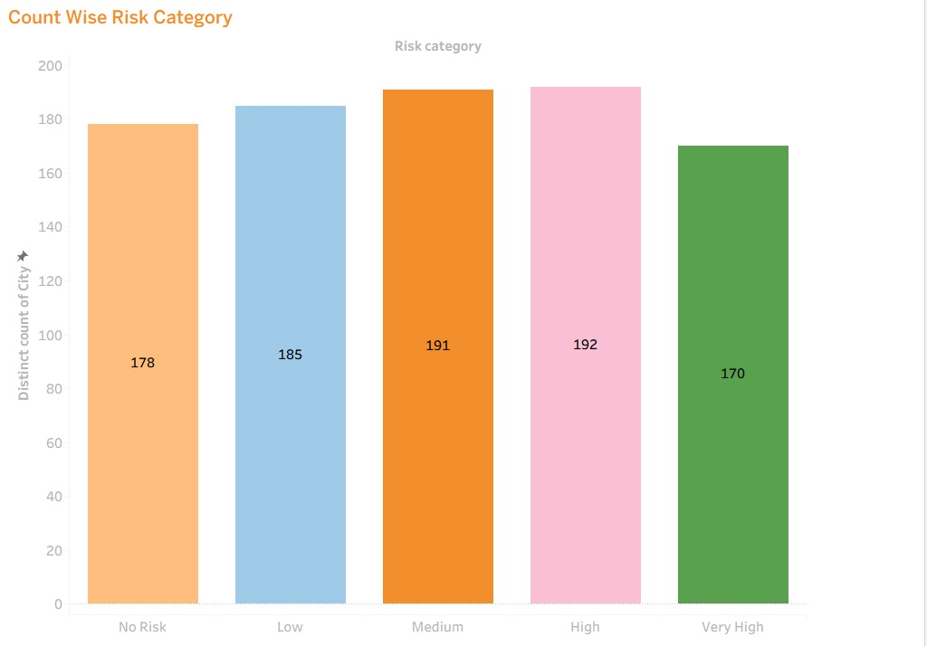
Insight:
Flood risk is widely distributed, with medium-to-high risk cities forming the majority, indicating the need for preventive planning rather than reactive response.

5.8.3. Elevation Category Distribution
- Low & Medium elevation zones have the highest counts.
- High elevation zones are fewer but still flood-affected.
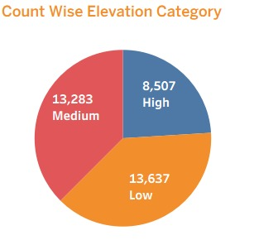
Insight:
Flood risk is not limited to low-lying areas—moderate elevations also experience significant flooding due to rainfall intensity and water flow.

5.8.4. Elevation vs Flood Risk Category
- No Risk: Highest average elevation (~2,621K m)
- Medium Risk: ~2,380K m
- Low Risk: ~1,668K m
- High Risk: ~1,514K m
- Very High Risk: Lowest elevation (~832K m)
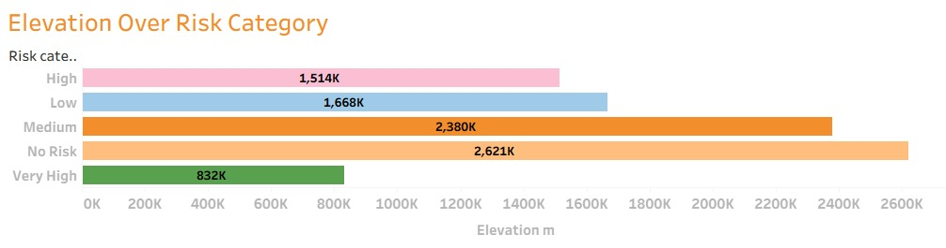
Insight:
Inverse relationship between elevation and flood risk
Lower elevation areas are significantly more vulnerable to severe flooding.

5.8.5. Average Monthly Rainfall Trend by Flood Risk Category
- Rainfall remains low from Jan–Apr across all categories.
- Sharp increase begins in May, peaks in July.
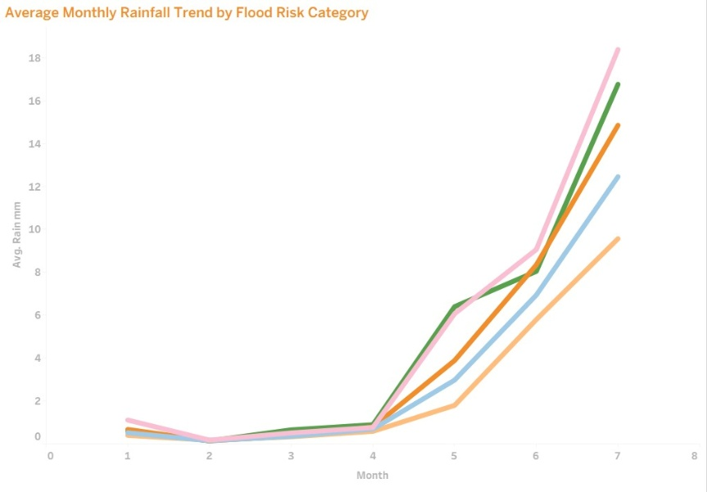
- Very High & High Risk areas receive the highest rainfall.
Insight:
Flood risk intensifies during monsoon months, especially in June–July, making this period critical for disaster preparedness.

5.8.6. Jan–Jun vs July Rainfall Comparison
- Jan–Jun: ~64.8K mm
- July alone: ~88.0K mm
Insight:
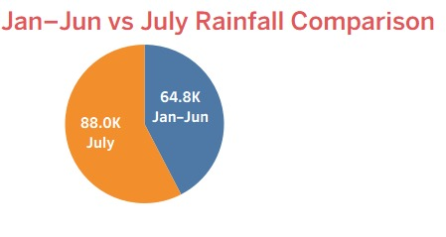
July receives more rainfall than the entire first six months combined, confirming it as the primary flood-triggering month.
5.8.7. Date-wise Average Rainfall Trend
- Rainfall fluctuates daily with clear peaks around days 19–25.
- Highest daily averages cross 6 mm.
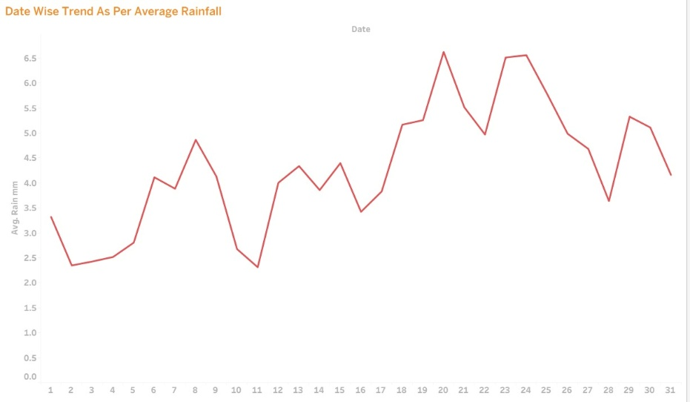
Insight:
Flood events are often driven by short-duration intense rainfall, not just monthly totals—important for early warning systems.

5.8.8. High Flood Risk over Landcover Class
Highest to lowest flood risk contribution:
- Forest
- Agriculture
- Urban
- Grassland
- Shrubland
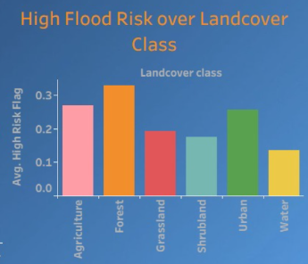
- Water bodies
Key Insights:
- Forest areas show high risk due to runoff from slopes and soil saturation.
- Agricultural lands are vulnerable due to soil erosion & poor drainage.
- Urban areas face risk from impervious surfaces and drainage overload.
5.8.9. Spatial (Map-Based) Insights
- Flood risk points are widely spread across India.
- Higher concentration seen in:
  - Eastern India
  - Coastal belts
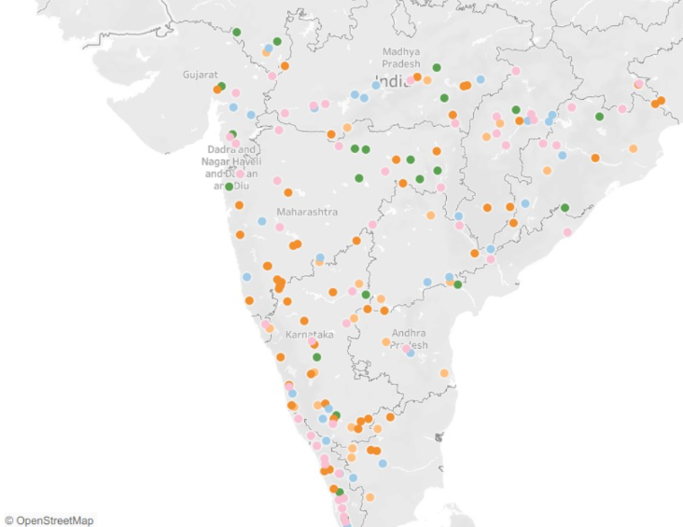
  - Central & Southern regions
Insight:
Flood risk is geographically widespread, requiring region-specific mitigation strategies, not a one-size-fits-all approach.

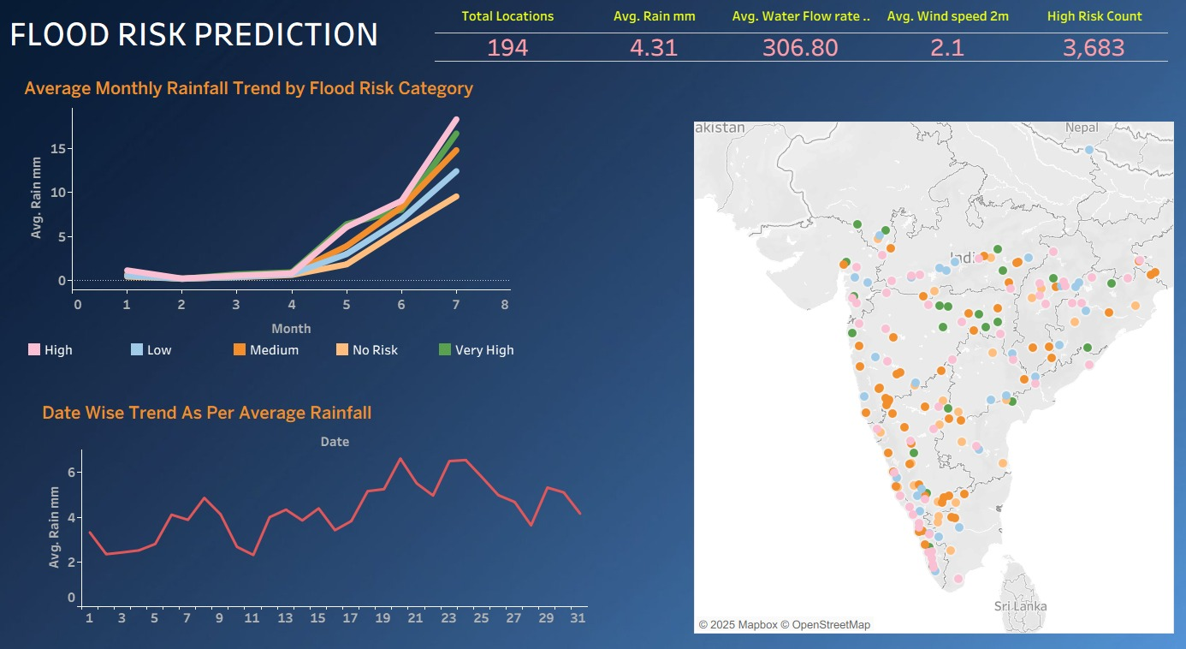
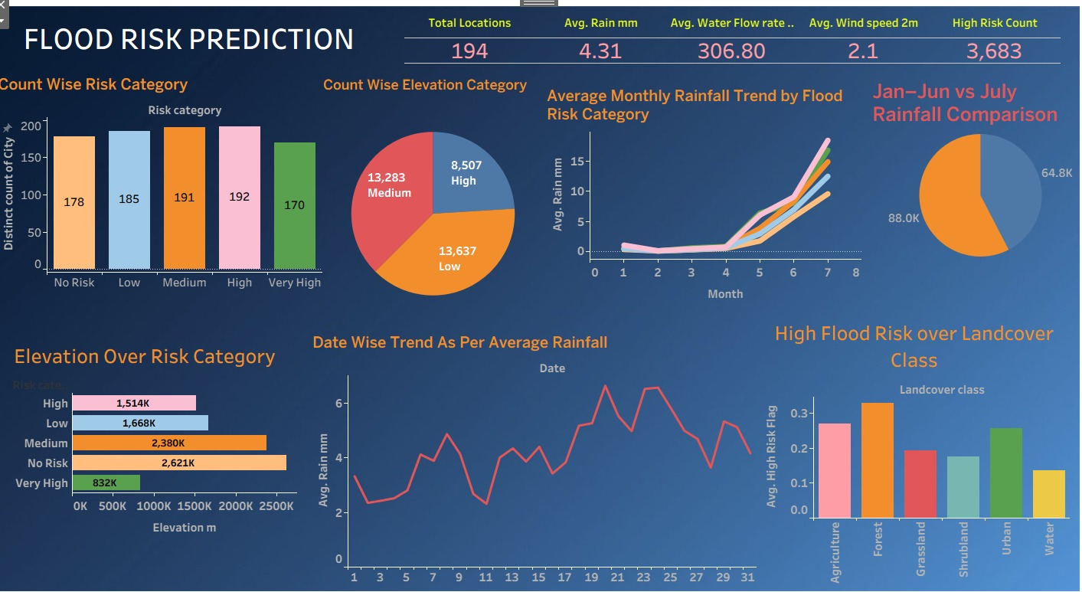
Dashboards :

6. Results and Findings
- Flood risk is strongly influenced by rainfall intensity and river level elevation.
- Urbanized regions with high impervious surfaces show increased flood vulnerability.
- Spatial analysis highlights region-specific flood hotspots.
- Machine learning models demonstrate reliable predictive performance for both occurrence and severity.

7. Expected Outcome
The system provides:
- Early flood risk indicators
- Predictive insights for disaster management authorities
- Improved preparedness and mitigation planning

8. Challenges
- Integration of multi-source datasets with different formats and resolutions
- Handling missing and noisy real-world data
- Maintaining prediction accuracy under rapidly changing weather conditions

9. Conclusion
This project successfully demonstrates an end-to-end flood risk prediction framework by combining data analytics, machine learning, GIS and visualization tools. The integration of statistical analysis, predictive modelling and spatial visualization provides a robust decision-support system for flood risk assessment and disaster management.

